USER MANUAL

HYBRID SOLAR INVERTER/CHARGER

# Table Of Contents

Table Of Contents 1

PRODUCT OVERVIEW 1

INSTALLATION 2

Unpacking and Inspection 2

Preparation 2

Mounting the Unit 2

Battery Connection 3

AC Input/Output Connection 4

PV Connection 6

Final Assembly 8

OPERATION 9

Power ON/OFF 9

Operation and Display Panel 9

LCD Setting 10

BATTERY EQUALIZATION 16

SETTING FOR LITHIUM BATTERY 18

Fault Reference Code 23

Warning Indicator 24

SPECIFICATIONS 25

Table 1 Line Mode Specifications 25

Table 2 Inverter Mode Specifications 26

Table 3 Charge Mode Specifications 27

Table 4 General Specifications 27

TROUBLE SHOOTING 28

# C:\Users\SMK\Desktop\0330\EM5.5K.pngEM5.5KPRODUCT OVERVIEW

1. LCD display
2. Status indicator
3. Charging indicator
4. Fault indicator
5. Function buttons
6. Power on/off switch
7. AC input
8. AC output
9. PV input
10. Battery input
11. RS232 communication port
12. RS485 communication port
13. Wire outlet hole
14. Grounding

# INSTALLATION

## Unpacking and Inspection

Before installation, please inspect the unit. Be sure that nothing inside the package is damaged. You should have received the following items inside of package:

1. The unit x 1
2. User manual x 1

## Preparation

Before connecting all wirings, please take off bottom cover by removing two screws as shown below.

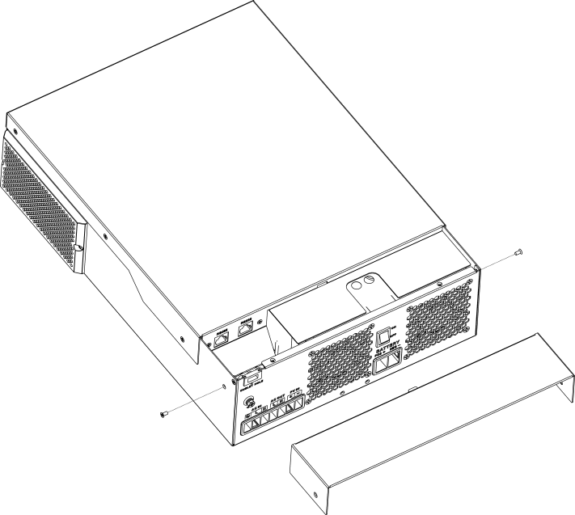

## Mounting the Unit

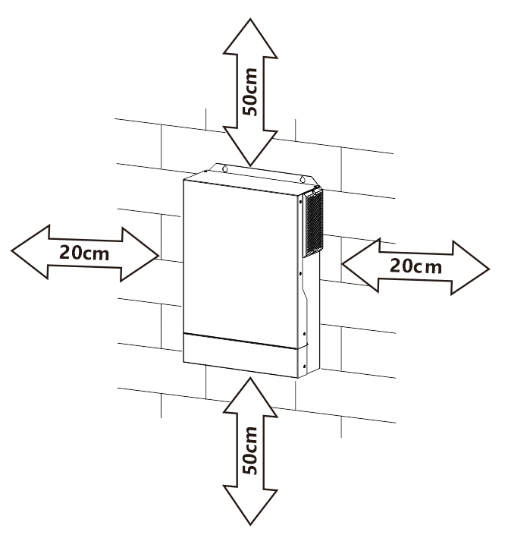Consider the following points before selecting where to install:

1. Do not mount the inverter on flammable construction materials.
2. Mount on a solid surface
3. Install this inverter at eye level in order to allow the LCD display to be read at all times.
4. The ambient temperature should be between 0°C and 55°C to ensure optimal operation.
5. The recommended installation position is to be adhered to the wall vertically.
6. Be sure to keep other objects and surfaces as shown in the right diagram to guarantee sufficient heat dissipation and to have enough space for removing wires.

#### SUITABLE FOR MOUNTING ON CONCRETE OR OTHER NON-COMBUSTIBLE SURFACE ONLY.

Install the unit by screwing three screws. It’s recommended to use M4 or M5 screws.

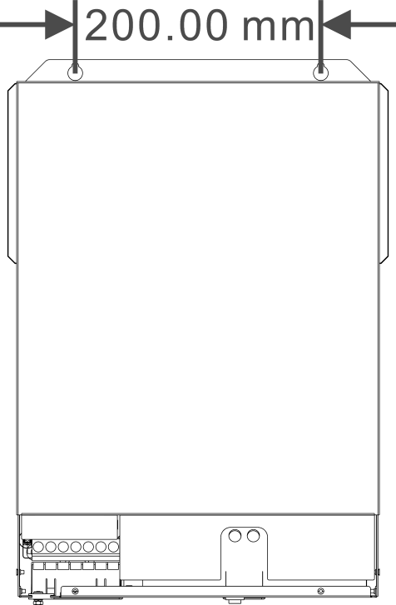

## Battery Connection

**CAUTION:** For safety operation and regulation compliance, it’s requested to install a separate DC over-current protector or disconnect device between battery and inverter. It may not be requested to have a disconnect device in some applications, however, it’s still requested to have over-current protection installed. Please refer to typical amperage in below table as required fuse or breaker size.

#### Stripping Length:

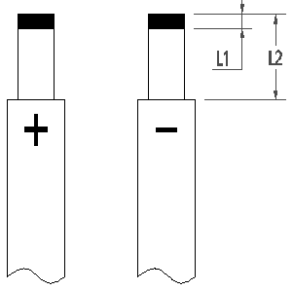**WARNING!** All wiring must be performed by a qualified personnel.

**WARNING!** It's very important for system safety and efficient operation to use appropriate cable for battery connection. To reduce risk of injury, please use the proper recommended cable 、stripping length(L2) and tinning length(L1)

as below.

#### Recommended battery cable 、stripping length (L2) and tinning length(L1):

|  |  |  |  |  |  |  |  |
| --- | --- | --- | --- | --- | --- | --- | --- |
| **Model** | **Maximum Amperage** | **Battery capacity** | **Wire Size** | **Cable**  **mm2** | **L1**  **(mm)** | **L 2**  **(mm)** | **Torque value** |
| All Models | 137A | 100AH | 2AWG | 38 | 3 | 18 | 2~ 3 Nm |

Please follow below steps to implement battery connection:

1. Remove insulation sleeve 18 mm for positive and negative cables based on recommended stripping length.
2. Connect all battery packs as units requires. It’s suggested to use recommended battery capacity.
3. Insert battery cable flatly into battery connector of inverter and make sure the bolts are tightened with torque of 2-3 Nm. Make sure polarity at both the battery and the inverter/charge is correctly connected and battery cables are tightly screwed to the battery connector.

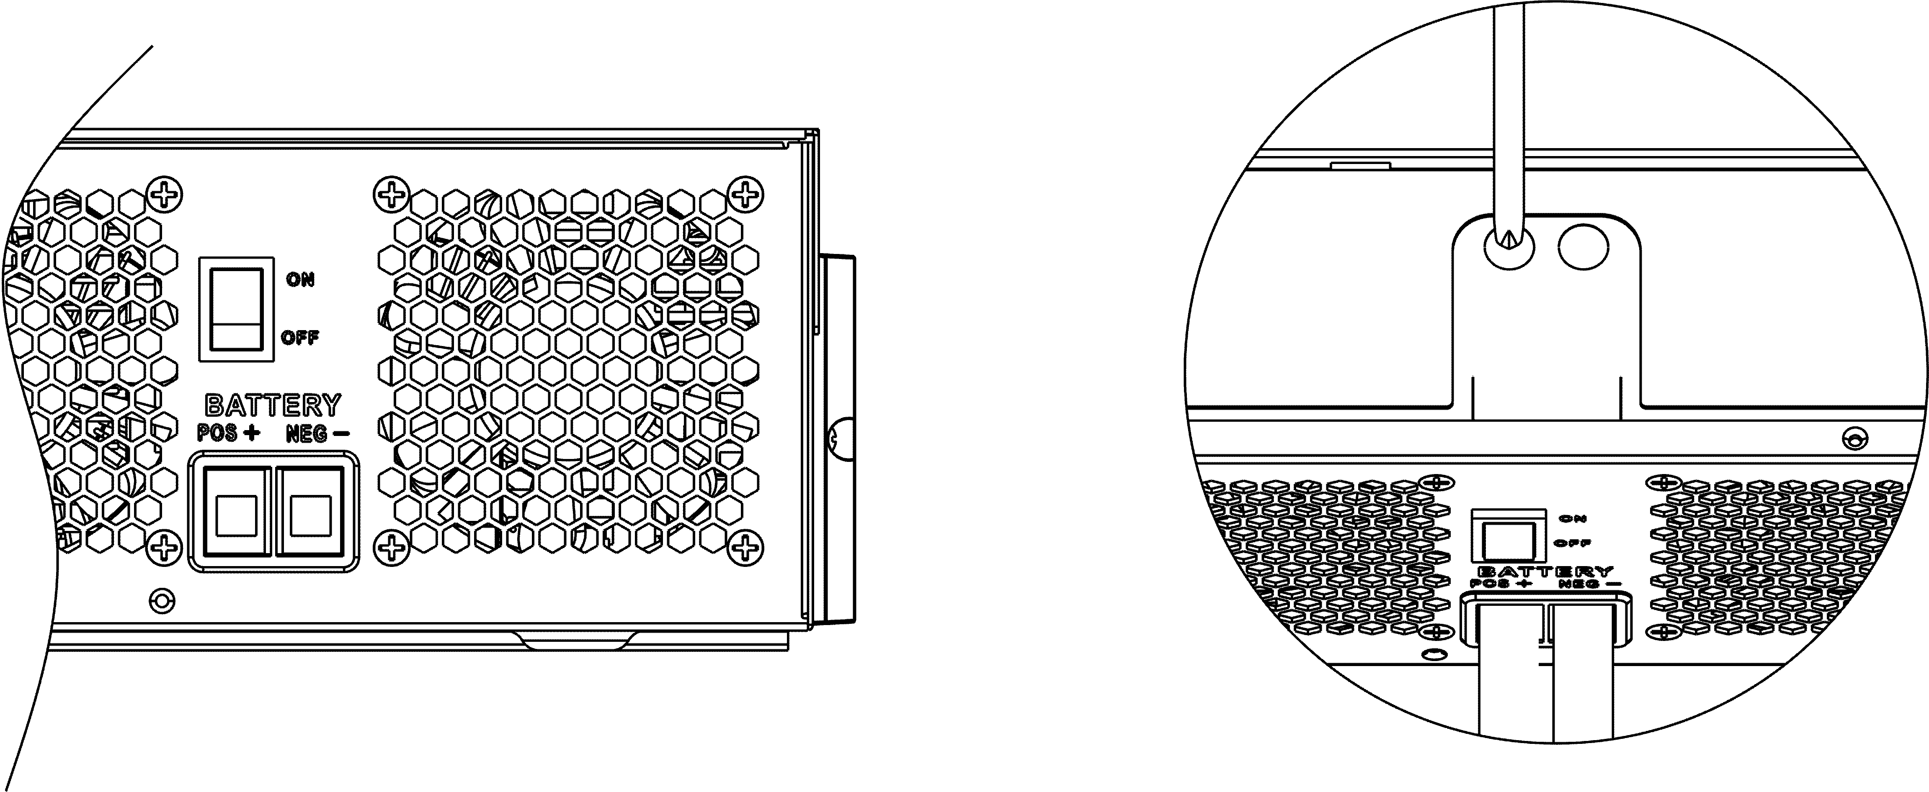

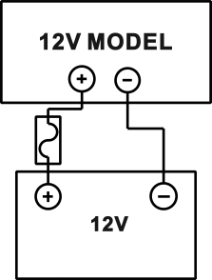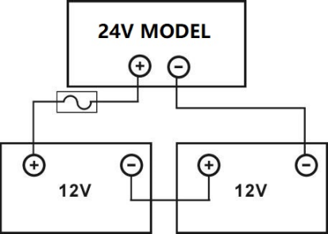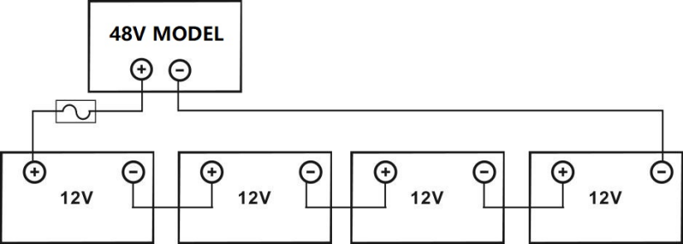

|  |  |
| --- | --- |
|  | **WARNING: Shock Hazard**  Installation must be performed with care due to high battery voltage in series. |

|  |  |
| --- | --- |
|  | **CAUTION!!** Do not place anything between the flat part of the inverter terminal Otherwise, overheating may occur.  **CAUTION!!** Do not apply anti-oxidant substance on the terminals before terminals are connected tightly.  **CAUTION!!** Before making the final DC connection or closing DC breaker/disconnector, be sure positive (+) must be connected to positive (+) and negative (-) must be connected to negative  (-). |

## AC Input/Output Connection

**CAUTION!!** Before connecting to AC input power source, please install a **separate** AC breaker between inverter and AC input power source. This will ensure the inverter can be securely disconnected during maintenance and fully protected from over current of AC input. The recommended spec of AC breaker is 50A. **CAUTION!!** There are two terminal blocks with “IN” and “OUT” markings. Please do NOT mis-connect input and output connectors.

**WARNING!** All wiring must be performed by a qualified personnel.

**WARNING!** It’s very important for system safety and efficient operation to use appropriate cable for AC input connection. To reduce risk of injury, please use the proper recommended cable size as below.

#### Suggested cable requirement for AC wires

|  |  |  |
| --- | --- | --- |
| **Model** | **Gauge** | **Torque Value** |
| 1.5KVA | 12AWG | 1.4~ 1.6Nm |
| 3.5KVA | 10AWG | 1.4~ 1.6Nm |
| 5.5KVA/6.2KVA | 8 AWG | 1.4~ 1.6Nm |

Please follow below steps to implement AC input/output connection:

1. Before making AC input/output connection, be sure to open DC protector or disconnector first.
2. Remove insulation sleeve 10mm for six conductors. And shorten phase L and neutral conductor N 3 mm.
3. Insert AC input wires according to polarities indicated on terminal block and tighten the terminal screws. Be sure to connect PE protective conductor (**)** first.

****→Ground (yellow-green) L→LINE (brown or black) N→Neutral (blue)

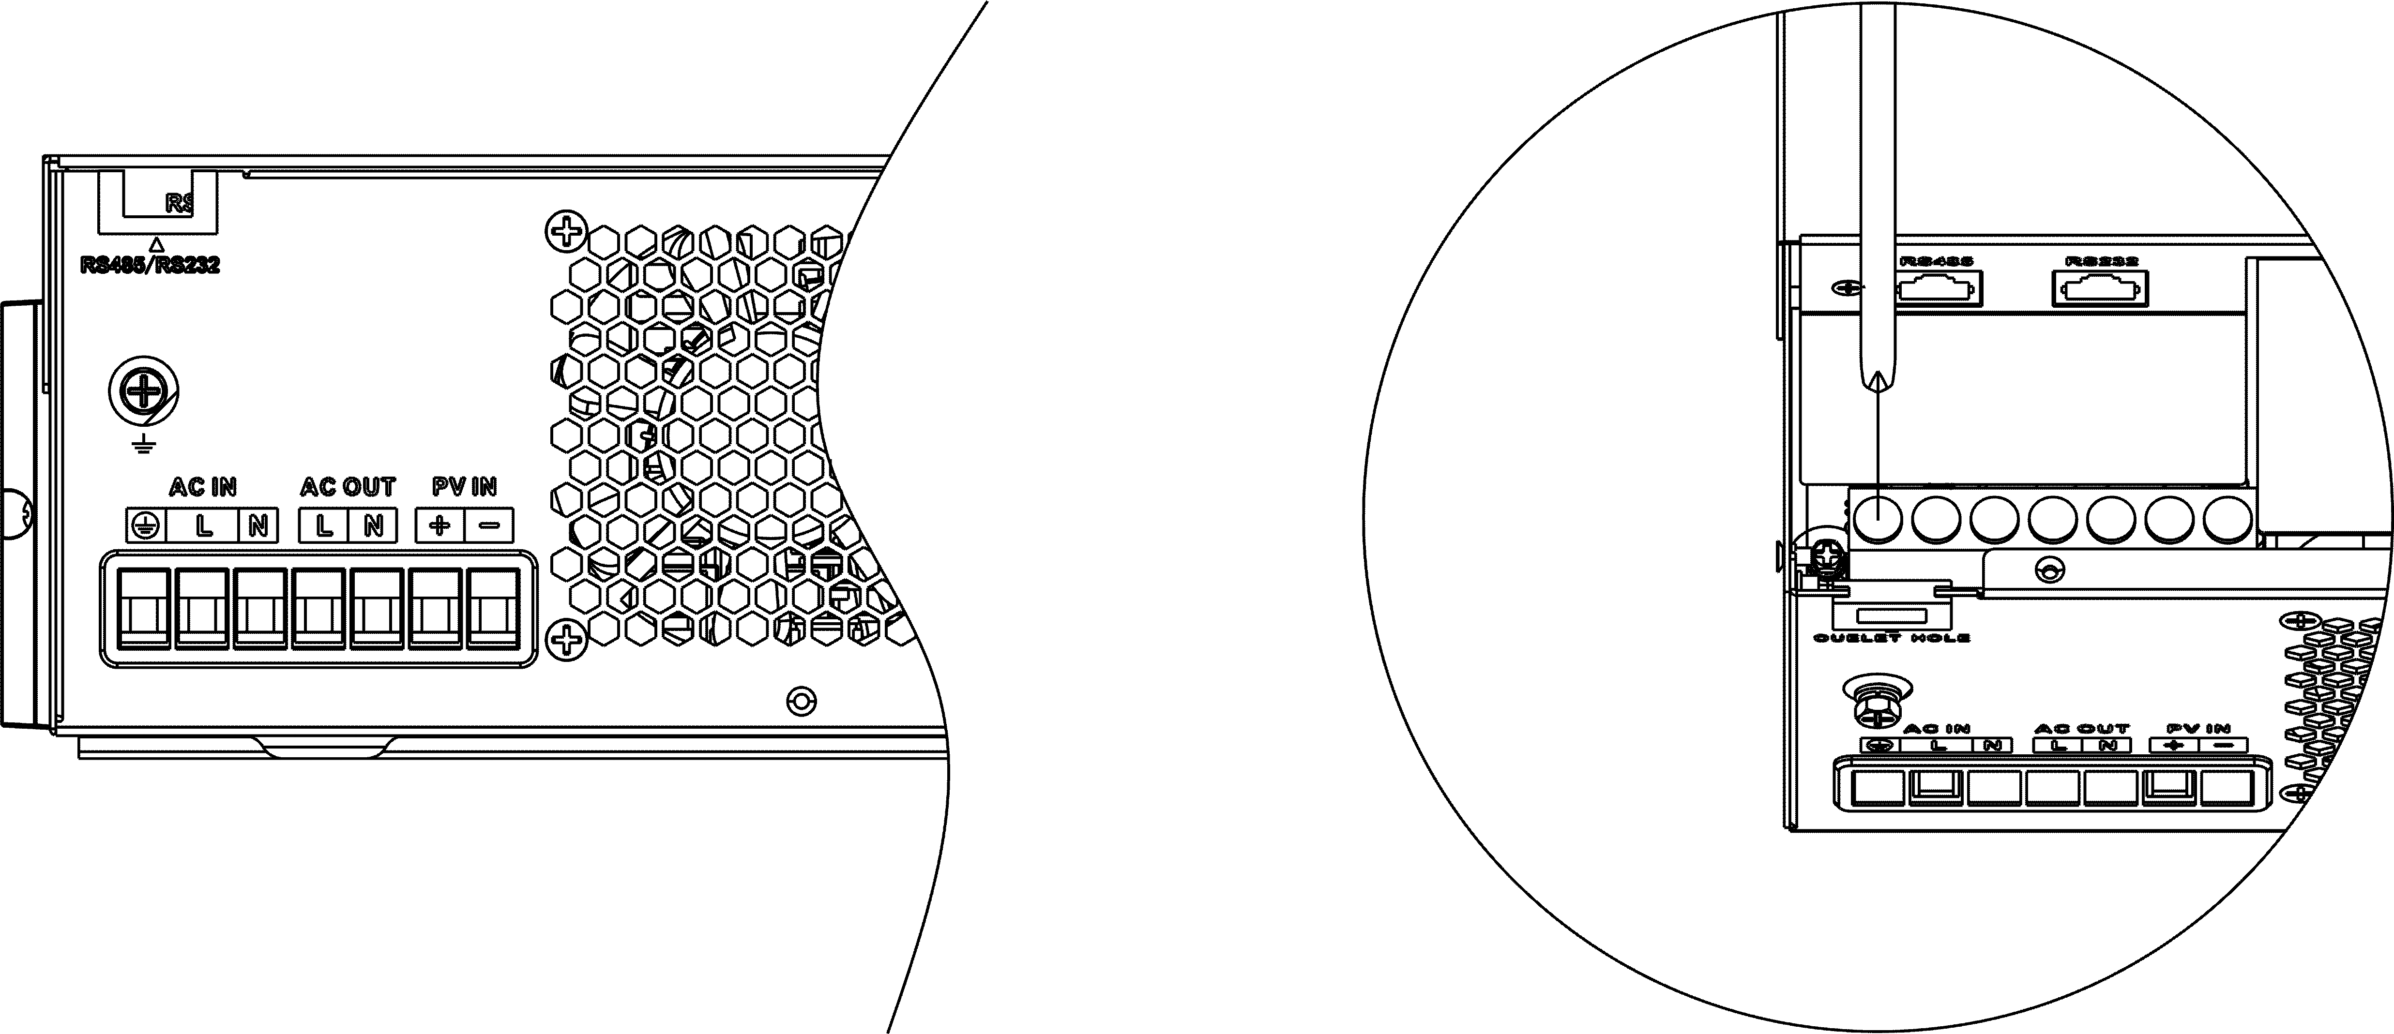

|  |  |
| --- | --- |
|  | **WARNING:**  Be sure that AC power source is disconnected before attempting to hardwire it to the unit. |

1. Then, insert AC output wires according to polarities indicated on terminal block and tighten terminal screws. Be sure to connect PE protective conductor (**)** first.

#### →Ground (yellow-green) L→LINE (brown or black)

#### N→Neutral (blue)

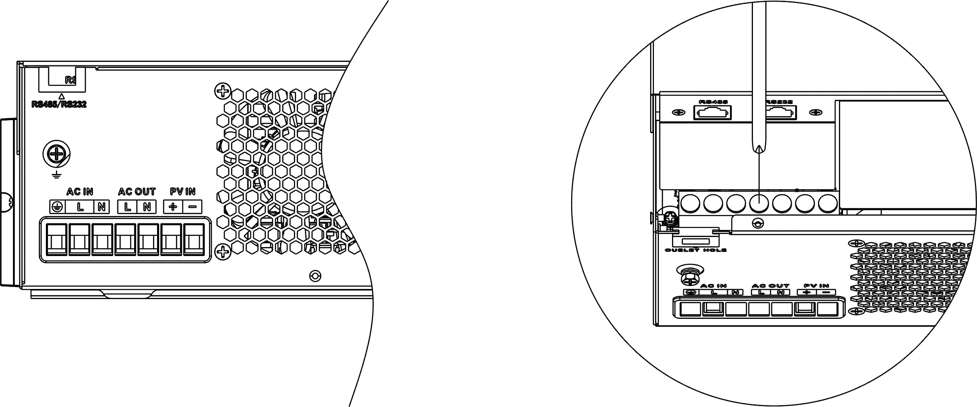

1. Make sure the wires are securely connected.

**CAUTION: Important**

Be sure to connect AC wires with correct polarity. If L and N wires are connected reversely, it may cause utility short-circuited when these inverters are worked in parallel operation.

**CAUTION:** Appliances such as air conditioner are required at least 2~3 minutes to restart because it’s required to have enough time to balance refrigerant gas inside of circuits. If a power shortage occurs and recovers in a short time, it will cause damage to your connected appliances. To prevent this kind of damage, please check manufacturer of air conditioner if it’s equipped with time-delay function before installation. Otherwise, this inverter/charger will trig overload fault and cut off output to protect your appliance but sometimes it still causes internal damage to the air conditioner.

## 

## PV Connection

**CAUTION:** Before connecting to PV modules, please install **separately** a DC circuit breaker between inverter and PV modules.

**WARNING!** All wiring must be performed by a qualified personnel.

**WARNING!** It'’ very important for system safety and efficient operation to use appropriate cable for PV module connection. To reduce risk of injury, please use the proper recommended cable size as below.

|  |  |  |  |
| --- | --- | --- | --- |
| **Model** | **Typical Amperage** | **Cable Size** | **Torque** |
| 1.5KVA（PVmax=160V） | 30A | 10 AWG | 1.4~1.6 Nm |
| 3.5KVA（PVmax=160V） | 40A | 8 AWG | 1.4~1.6 Nm |
| 3.5KVA | 15A | 12 AWG | 1.4~1.6 Nm |
| 5.5KVA | 18A | 12 AWG | 1.4~1.6 Nm |
| 6.2KVA | 27A | 12 AWG | 1.4~1.6 Nm |

#### PV Module Selection:

When selecting proper PV modules, please be sure to consider below parameters:

1. Open circuit Voltage (Voc) of PV modules not exceeds max. PV array open circuit voltage of inverter.
2. Open circuit Voltage (Voc) of PV modules should be higher than min. battery voltage.

|  |  |  |  |  |  |
| --- | --- | --- | --- | --- | --- |
| **Solar Charging Mode** | | | | | |
| **INVERTER MODEL** | 3.5KVA | 5.5KVA | 6.2KVA | 1.5K~3.5KVA  (PVmax=160V) | |
| **Max. PV Array Open Circuit Voltage** | 500DC | | | 160VDC | |
| **PV Array MPPT Voltage Range** | 60VDC~500VDC | | | 30-160V | |
| **Max. PV INPUT CURRENT** | 15A | 18A | 27A | 30A(1.5K) | 50A(3.5K) |

Take the 450Wp and 550Wp PV module as an example. After considering above two parameters, the recommended module configurations are listed in the table below.

|  |  |  |  |  |
| --- | --- | --- | --- | --- |
| Solar Panel Spec. (reference)  - 450Wp   * Vmp: 34.67Vdc * Imp: 13.82A * Voc: 41.25Vdc * Isc: 12.98A | SOLAR INPUT | Q'ty of panels | Total input power | Inverter Model |
| 3 pcs in serial | 3 pcs | 1,350 W | 3.5KVA/5.5KVA/6.2KVA |
| 4 pcs in serial | 4 pcs | 1,800 W |
| 5 pcs in serial | 5 pcs | 2,250 W |
| 6 pcs in serial | 6 pcs | 2,700 W |
| 7 pcs in serial | 7 pcs | 3,150 W |
| 8 pcs in serial | 8 pcs | 3,600 W |
| 9 pcs in serial | 9 pcs | 4,050 W |
| 10 pcs in serial | 10 pcs | 4,500 W | 5.5KVA/6.2KVA |
| 11 pcs in serial | 11 pcs | 4,950 W |
| 12 pcs in serial | 12 pcs | 5,400 W |
| 6 pieces in serial and 2 sets in parallel | 12 pcs | 5,400 W | 6.2KVA |
| 8 pieces in serial and 2 sets in parallel | 14 pcs | 6,300 W |
| 1 pcs in serial | 1 pcs | 450W | 3.5KVA(PVmax=160V) |
| 2 pcs in serial | 2 pcs | 900W |
| 3 pcs in serial | 3 pcs | 1,350 W |
| Solar Panel Spec. (reference)  - 550Wp   * Vmp: 42.48Vdc * Imp: 12.95A * Voc: 50.32Vdc * Isc: 13.70A | SOLAR INPUT | Q'ty of panels | Total input power | Inverter Model |
| 3 pcs in serial | 3 pcs | 1,650 W | 3.5KVA/5.5KVA/6.2KVA |
| 4 pcs in serial | 4 pcs | 2,200 W |
| 5 pcs in serial | 5 pcs | 2,750 W |
| 6 pcs in serial | 6 pcs | 3,300 W |
| 7 pcs in serial | 7 pcs | 3,850 W |
| 8 pcs in serial | 8 pcs | 4,400 W | 5.5KVA/6.2KVA |
| 9 pcs in serial | 9 pcs | 4,950 W |
| 10 pcs in serial | 10 pcs | 5,500 W | 5.5KVA/6.2KVA |
| 11 pcs in serial | 11 pcs | 6,050 W | 6.2KVA |
| 12 pcs in serial | 12 pcs | 6,600 W |
| 4 pieces in serial and 2 sets in parallel | 8 pcs | 4,400 W | 6.2KVA |
| 5 pieces in serial and 2 sets in parallel | 10 pcs | 5,500 W |
| 6 pieces in serial and 2 sets in parallel | 12 pcs | 6,600 W |
| 1 pcs in serial | 1 pcs | 550W | 1.5K/3.5KVA(PVmax=160V) |
| 2 pcs in serial | 2 pcs | 1000W | 1.5K/3.5KVA(PVmax=160V) |
| 3 pcs in serial | 3 pcs | 1,500 W | 3.5KVA(PVmax=160V) |

#### PV Module Wire Connection:

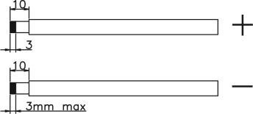Please follow below steps to implement PV module connection:

1. Remove insulation sleeve 10 mm for positive and negative conductors.
2. Check correct polarity of connection cable from PV modules and PV input connectors. Then, connect positive pole (+) of connection cable to positive pole (+) of PV input connector. Connect negative pole (-) of connection cable to negative pole (-) of PV input connector.

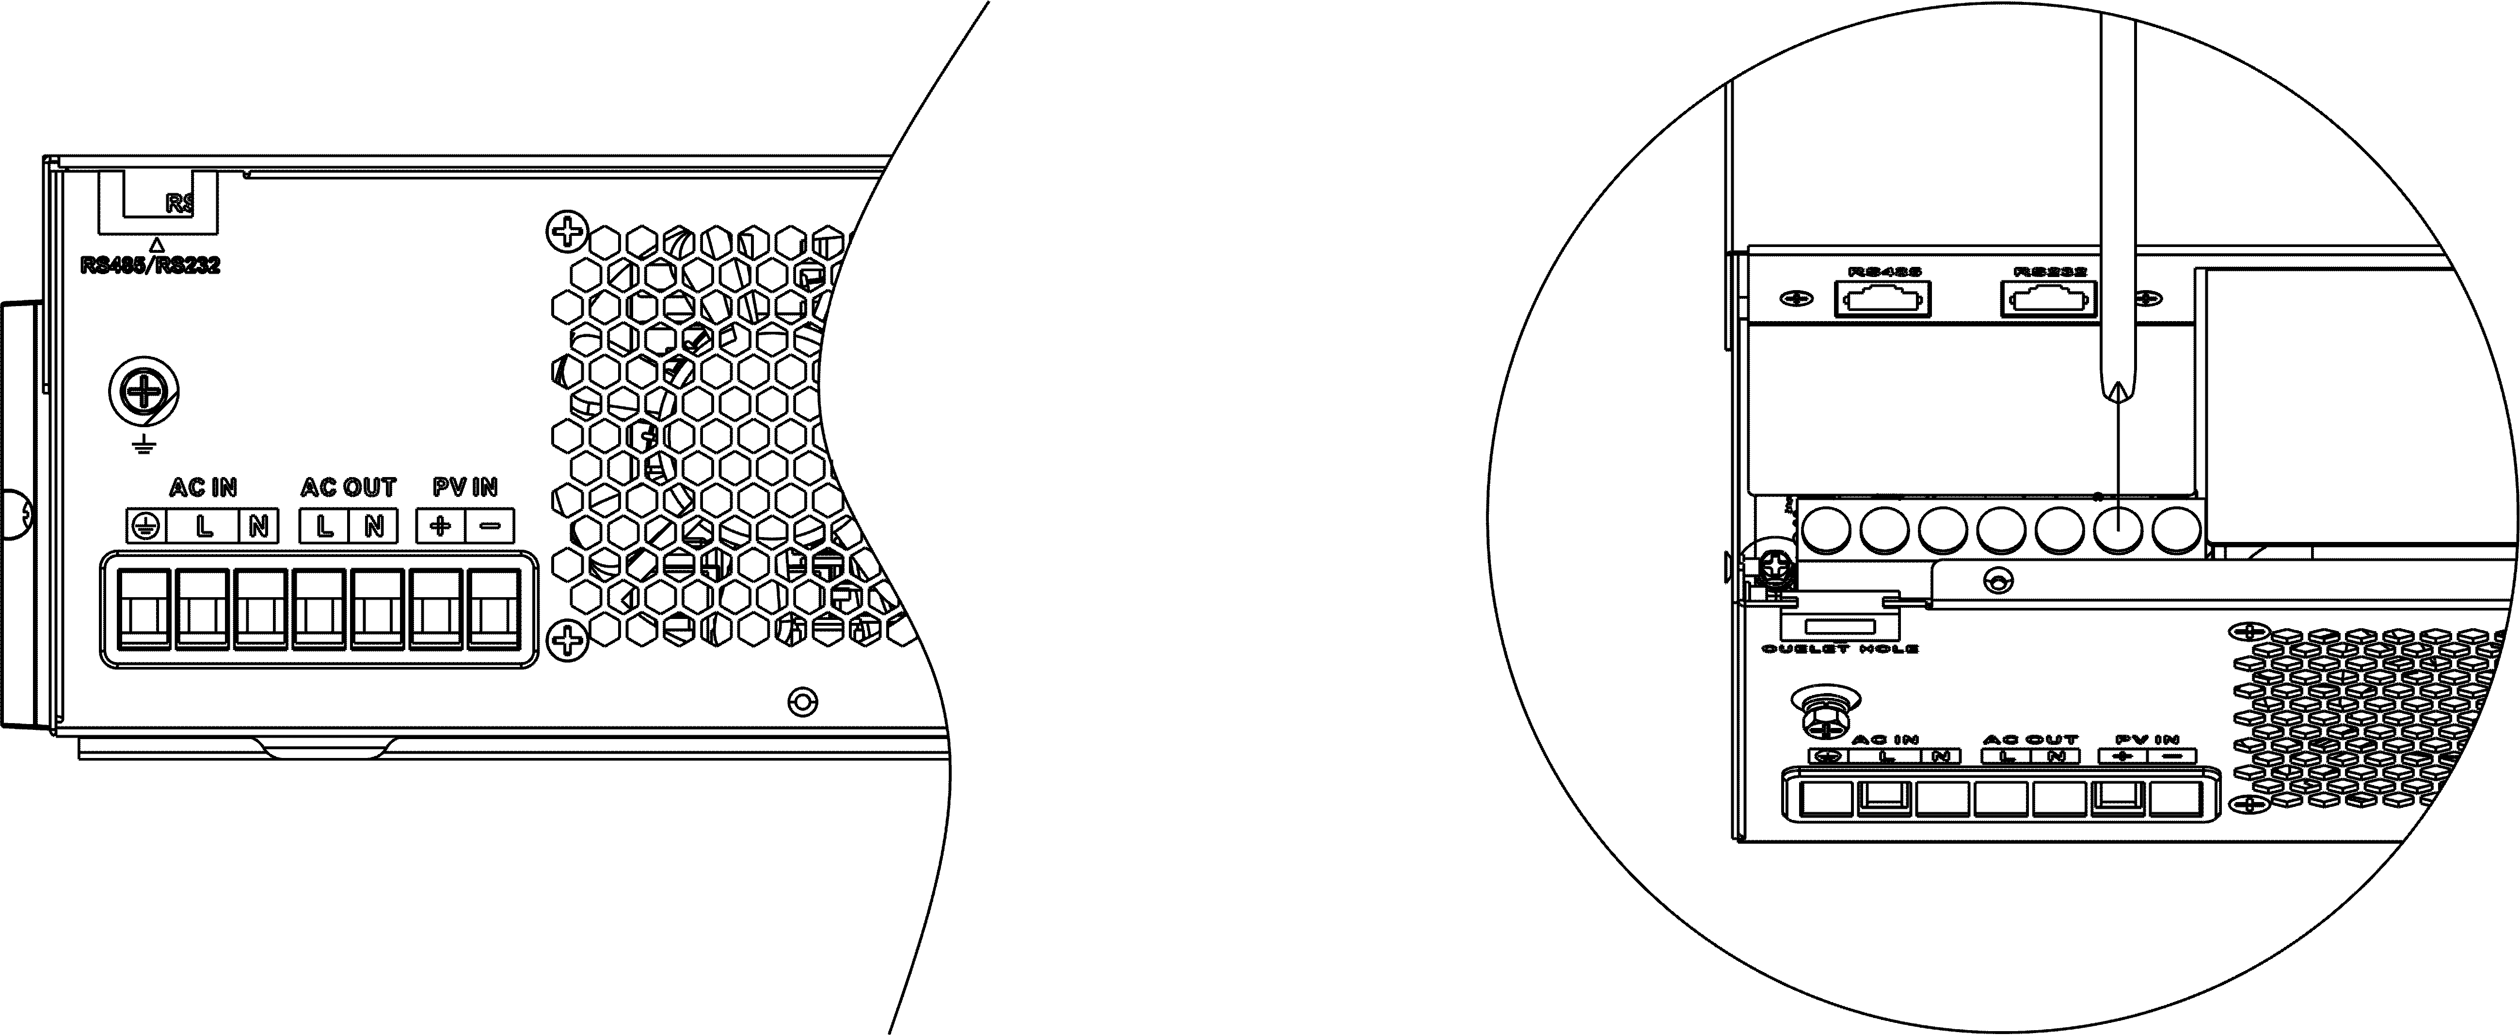

1. Make sure the wires are securely connected.

## Final Assembly

After connecting all wirings, please put bottom cover back by screwing two screws as shown below.

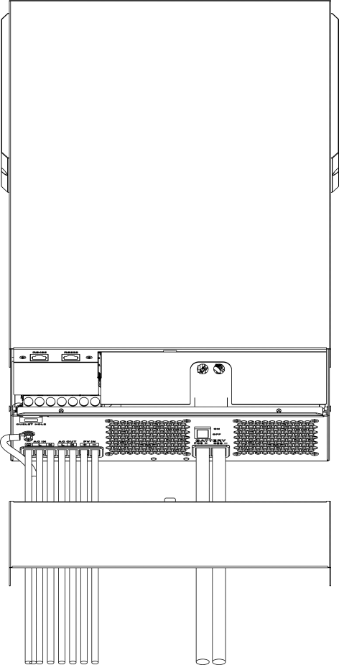

# OPERATION

## Power ON/OFF

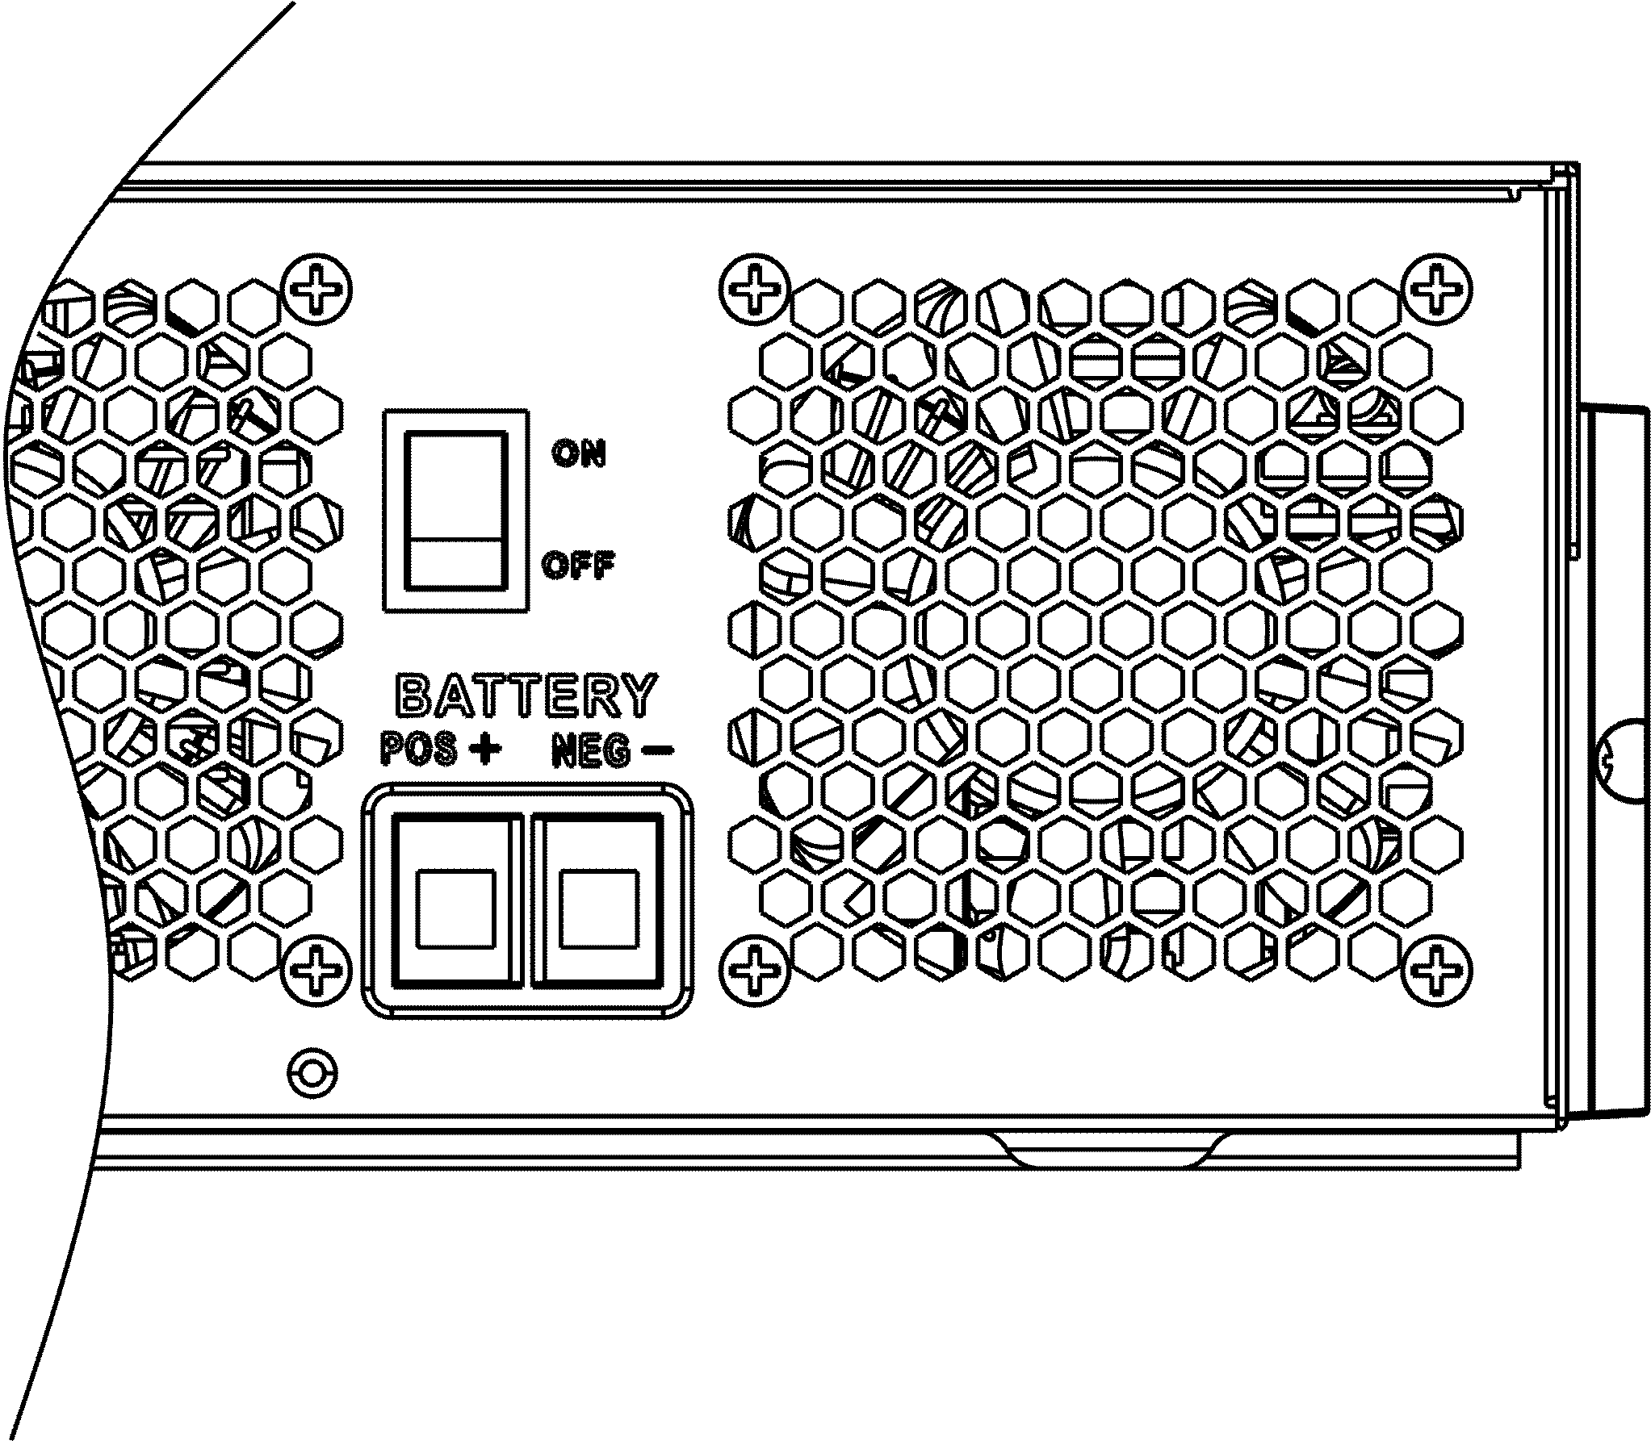

Once the unit has been properly installed and the batteries are connected well, simply press On/Off switch (located on the button of the case) to turn on the unit.

## Operation and Display Panel

The operation and display panel, shown in below chart, is on the front panel of the inverter. It includes three indicators, four function keys and a LCD display, indicating the operating status and input/output power information.

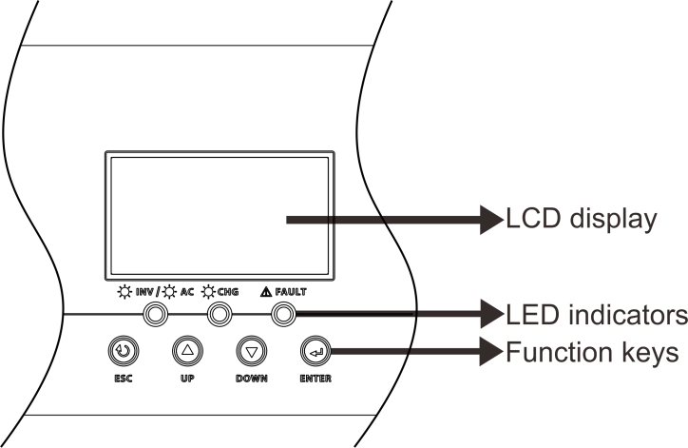

#### LED Indicator

|  |  |  |  |
| --- | --- | --- | --- |
| **LED Indicator** | | | **Messages** |
|  | Green | Solid On | Output is powered by utility in Line mode. |
| Flashing | Output is powered by battery or PV in battery mode. |
|  | Green | Solid On | Battery is fully charged. |
| Flashing | Battery is charging. |
|  | Red | Solid On | Fault occurs in the inverter. |
| Flashing | Warning condition occurs in the inverter. |

#### Function Keys

|  |  |
| --- | --- |
| **Function Key** | **Description** |
| ESC | To exit setting mode |
| UP | To go to previous selection |
| DOWN | To go to next selection |
| ENTER | To confirm the selection in setting mode or enter setting mode |

## LCD Setting

After pressing and holding ENTER button for 3 seconds, the unit will enter setting mode. Press “UP” or “DOWN” button to select setting programs. And then, press “ENTER” button to confirm the selection or ESC button to exit.

#### Setting Programs:

|  |  |  |  |
| --- | --- | --- | --- |
| **Program** | **Description** | **Selectable option** | |
| 01 | Output source priority: To configure load power source priority | Solar first | Solar energy provides power to the loads as first priority.  If solar energy is not sufficient to power all connected loads, battery energy will supply power the loads at the same time.  Utility provides power to the loads only when any one condition happens:   * Solar energy is not available * Battery voltage drops to either low-level warning voltage or the setting point in program 12. |
| Utility first (default) | Utility will provide power to the loads as first priority.  Solar and battery energy will provide power to the loads only when utility power is not available. |
| SBU priority | Solar energy provides power to the loads as first priority.  If solar energy is not sufficient to power all connected loads, battery energy will supply power to the loads at the same time.  Utility provides power to the loads only when battery voltage drops to either low-level warning voltage or the setting point in program 12. |
| SUB priority | Solar energy is charged first and then power to the loads.  If solar energy is not sufficient to  power all connected loads, Utility  energy will supply power to the  loads at the same time.  Note：SUB priority is just for PVmax=500Vdc model. |
| 02 | Maximum charging current: To configure total charging current for solar and utility chargers.  (Max. charging current = utility charging current + solar charging current) | 60A (default) | If selected, acceptable charging current range will be from Max. AC charging current to Max. charging current of SPEC，but it shouldn’t be less than the AC charging current （program 11） |
| 03 | AC input voltage range | Appliances (default) | If selected, acceptable AC input voltage range will be within  90-280VAC. |
| UPS | If selected, acceptable AC input  voltage range will be within 170-280VAC. |
| Generator   | If selected, acceptable AC input  voltage range will be within 170-280VAC and compatible with generators.  Note: Because generators are  unstable, maybe the output of inverter will be unstable too. |
| 05 | Battery type | AGM (default) | Flooded |
| User-Defined | If “User-Defined” is selected, battery charge voltage and low DC cut-off voltage can be set up in program 26,  27 and 29. |
| C:\Users\admin\Desktop\标准说明升版以及升版说明\替换图片\LI2.pngLI2 | Support PYLON US2000 Protocol  3.5 Version |
| C:\Users\admin\Desktop\标准说明升版以及升版说明\替换图片\LI4.pngLI4 | Standard communication Protocol form inverter supplier |
| 06 | Auto restart when overload occurs | Restart disable | Restart enable (default) |
| 07 | Auto restart when over temperature occurs | Restart disable | Restart enable (default) |
| 08 | Output voltage | 220V | 230V (default) |
| 240V |  |
| 09 | Output frequency | 50Hz (default) | 60Hz |
| 10 | Auto bypass  When selecting “auto”, if the mains power is normal, it will automatically bypass, even if the switch is off. | manual(default) | auto |
| 11 | Maximum utility charging current | 30A (default)    If selected, acceptable charging current range will be within 2- Max. AC charging current of SPEC. | |
| 12 | Setting voltage point back to utility source when selecting “SBU priority” or “Solar first” in program 01. | **48V models:**46V (default)  Setting range is from 44.0V to 57.2V for 48v model, but the max setting value must be less than the value of program13. | |
| **24V models:**23V (default)  Setting range is from 22.0V to 28.6V for 24v model, but The max setting value must be less than the value of program13. | |
| **12V models:**11.5V (default)  Setting range is from 11.0V to 14.3V for 12v model, but The max setting value must be less than the value of program13. | |
| 13 | Setting voltage point back to battery mode when selecting “SBU priority” or “Solar first” in program 01. | Battery fully charged  (default) | **48V models:**  Setting range is from 48V to full (the value of program26-0.4V), but the max setting value must be more than the value of program12.  **24V models:**  Setting range is from 24V to full (the value of program26-0.4V), but the max setting value must be more than the value of program12.  **12V models:**  Setting range is from 12V to full (the value of program13-0.4V), but the max setting value must be more than the value of program12. |

|  |  |  |  |  |
| --- | --- | --- | --- | --- |
| 16 | Charger source priority:  To configure charger source priority | If this inverter/charger is working in Line, Standby or Fault  mode, charger source can be programmed as below: | | |
| Solar first | Solar energy will charge battery as first priority.  Utility will charge battery only when  solar energy is not available. | |
| Solar and Utility (default) | Solar energy and utility will charge battery at the same time. | |
| Only Solar | Solar energy will be the only charger source no matter utility is available  or not. | |
| If this inverter/charger is working in Battery mode, only solar energy can charge battery. Solar  energy will charge battery if it's available and sufficient. | | |
| 18 | Buzzer mode | Mode1  C:\Users\Administrator\Desktop\00\图片6.png图片6 | Buzzer mute | |
| Mode2  C:\Users\Administrator\Desktop\00\图片5.png图片5 | The buzzer sounds when the input source changes or there is a specific warning or fault | |
| Mode3  C:\Users\Administrator\Desktop\00\图片4.png图片4 | The buzzer sounds when there is a specific warning or fault | |
| Mode4(default)  C:\Users\Administrator\Desktop\00\图片3.png图片3 | The buzzer sounds when there is a fault | |
| 19 | Auto return to default display screen | Return to default display  screen (default) | If selected, no matter how users switch display screen, it will automatically return to default display screen (Input voltage  /output voltage) after no button is  pressed for 1 minute. | |
| Stay at latest screen  C:\Users\SMK-Jary\Desktop\图片1.png图片1 | If selected, the display screen will stay at latest screen user finally switches. | |
| 20 | Backlight control | Backlight on (default) | Backlight off | |
| 23 | Overload bypass:  When enabled, the unit will transfer to line mode if overload occurs in battery mode. | Bypass disable  C:\Users\admin\Desktop\标准说明升版以及升版说明\替换图片\BYD.pngBYD | Bypass enable(default) | |
| 25 | Modbus ID Setting | Modbus ID Setting Range ：001(default)~247 | | |
| 26 | Bulk charging voltage (C.V voltage) | If self-defined is selected in program 5, this program can be set  up. But the setting value must be more than or equal the value of program27. Increment of each click is 0.1V.  12V models: Default 14.1V, setting range is from 12.0V to 15.5V,  24V models: Default 28.2V, setting range is from 24.0V to 30.0V ,  48V models: Default 56.4V, setting range is from 48.0V to 62.0V. | | |
| 27 | Floating charging voltage | If self-defined is selected in program 5, this program can be set  up.  12V models default setting: 13.5V  Setting range is from 12.0V to the value of program 26  24V models default setting: 27.0V  Setting range is from 24.0V to the value of program 26  48V models default setting: 54.0V  Setting range is from 48.0V to the value of program 26 | | |
| 29 | Low DC cut-off voltage | If self-defined is selected in program 5, this program can be set up.  The setting value must be less than the value of program12. Increment of each click is 0.1V.Low DC cut-off voltage will be fixed to setting value no matter what percentage of load is connected.  12V models default setting: 10.5v  Setting range is from 10.0V to 13.5V  24V models default setting: 21.0v  Setting range is from 20.0V to 27.0V  48V models default setting: 42.0V  Setting range is from 40.0V to 54.0V | | |
| 32 | Bulk charging time (C.V stage) | Automatically (Default): | | If selected, inverter will judge this charging time automatically. |
| 5 min | | The setting range is from 5 min to 900 min. Increment of each click is 5 min. |
| 900 min | |
| If “USE” is selected in program 05, this program can be set up. | | |
| 33 | Battery equalization | Battery equalization | | Battery equalization disable (default) |
| If “Flooded” or “User-Defined” is selected in program 05, this program can be set up. | | |

|  |  |  |  |  |
| --- | --- | --- | --- | --- |
| 34 | Battery equalization voltage | 12V models default setting is 14.6V. Setting range is from floating voltage ~ 15.5V. Increment of each click is 0.1V.  24V models default setting is 29.2V. Setting range is from floating voltage ~ 31V. Increment of each click is 0.1V.  48V models default setting is 58.4V. Setting range is from floating voltage ~ 64V. Increment of each click is 0.1V. | | |
| 35 | Battery equalized time | 60min (default) | Setting range is from 0 min to 900min. | |
| 36 | Battery equalized timeout | 120min (default) | Setting range is from 0min to  900 min. | |
| 37 | Equalization interval | 30days (default) | Setting range is from 1 to 90 days. | |
| 39 | Equalization activated immediately | Enable | Disable (default) | |
| If equalization function is enabled in program 33, this program can be set up. If “Enable” is selected in this program, it’s to activate battery equalization immediately and LCD main page will shows “ ”. If “Disable” is selected, it will cancel equalization function until next activated equalization time arrives based on program 37 setting. At this time, “” will  not be shown in LCD main page.. | | |
| 41 | Automatic activation for lithium battery |  | | Disable automatic activation  (default) |
|  | | When Program05 is selected “LIx” as lithium battery and when the battery is not detected, the unit will activate automatically the lithium battery at a time. If you want to activate automatically the lithium battery，you must restart the unit. |
| 42 | Manual activation for lithium battery |  | | Default: disable activation |
|  | | When Program05 is selected “LIx” as lithium battery, when the battery is not detected, If you want to activate the lithium battery at a time, you could selected it. |
| 43 | Setting SOC point back to utility source when selecting “SBU priority” or “Solar first” in program 01 |  | | Default 50%, 20%~50% Settable |
| 44 | Setting SOC point back to battery mode when selecting “SBU priority” or “Solar first “in program 01 |  | | Default 95%, 60%~100% Settable |
| 45 | Low DC cut-off SOC |  | | Default 20%, 3%~30% Settable |
| 46 | Maximum discharge current protection |  | | Default OFF  Disable current discharge current protection function |
|  | | When the discharge current exceeds setting value, the battery will stop discharging. The setting range is from 20A to 500A. |

# BATTERY EQUALIZATION

Equalization function is added into charge controller. It reverses the buildup of negative chemical effects like stratification, a condition where acid concentration is greater at the bottom of the battery than at the top. Equalization also helps to remove sulfate crystals that might have built up on the plates. If left unchecked, this condition, called sulfation, will reduce the overall capacity of the battery. Therefore, it’s recommended to equalize battery periodically.

#### How to Apply Equalization Function

You must enable battery equalization function in monitoring LCD setting program 33 first. Then, you may apply this function in device by either one of following methods:

1. Setting equalization interval in program 37.
2. Active equalization immediately in program 39.

#### When to Equalize

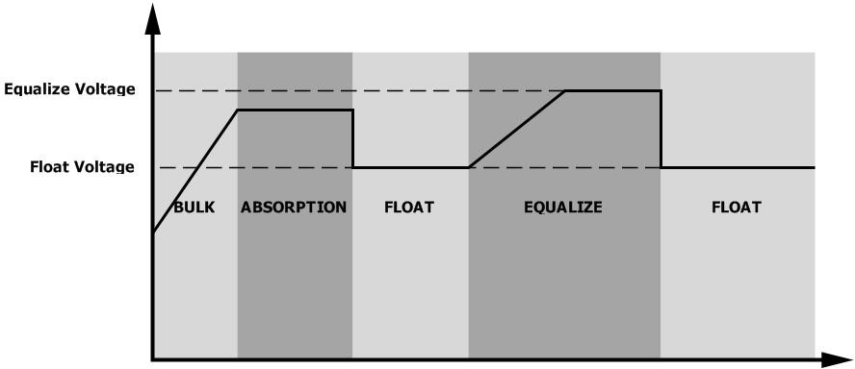In float stage, when the setting equalization interval (battery equalization cycle) is arrived, or equalization is active immediately, the controller will start to enter Equalize stage.

#### Equalize charging time and timeout

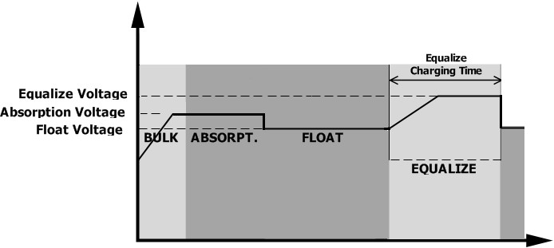In Equalize stage, the controller will supply power to charge battery as much as possible until battery voltage raises to battery equalization voltage. Then, constant-voltage regulation is applied to maintain battery voltage at the battery equalization voltage. The battery will remain in the Equalize stage until setting battery equalized time is arrived.

However, in Equalize stage, when battery equalized time is expired and battery voltage doesn’t rise to battery equalization voltage point, the charge controller will extend the battery equalized time until battery voltage achieves battery equalization voltage. If battery voltage is still lower than battery equalization voltage when battery equalized timeout setting is over, the charge controller will stop equalization and return to float stage.

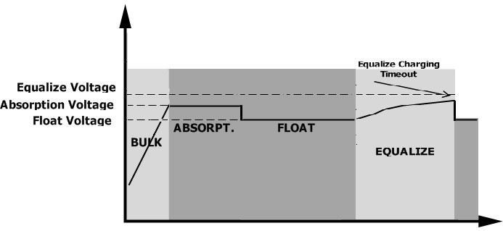

# SETTING FOR LITHIUM BATTERY

#### Lithium Battery Connection

If choosing lithium battery for the inverter, you are allowed to use the lithium battery only which we have configured. There’re two connectors on the lithium battery, RS485 port of BMS and power cable.

Please follow below steps to implement lithium battery connection:

1). Assemble battery terminal based on recommended battery cable and terminal size (same as Lead acid, see section Lead-acid Battery connection for details).

2). Connect the end of RS485 port of battery to BMS(RS485) communication port of inverter.

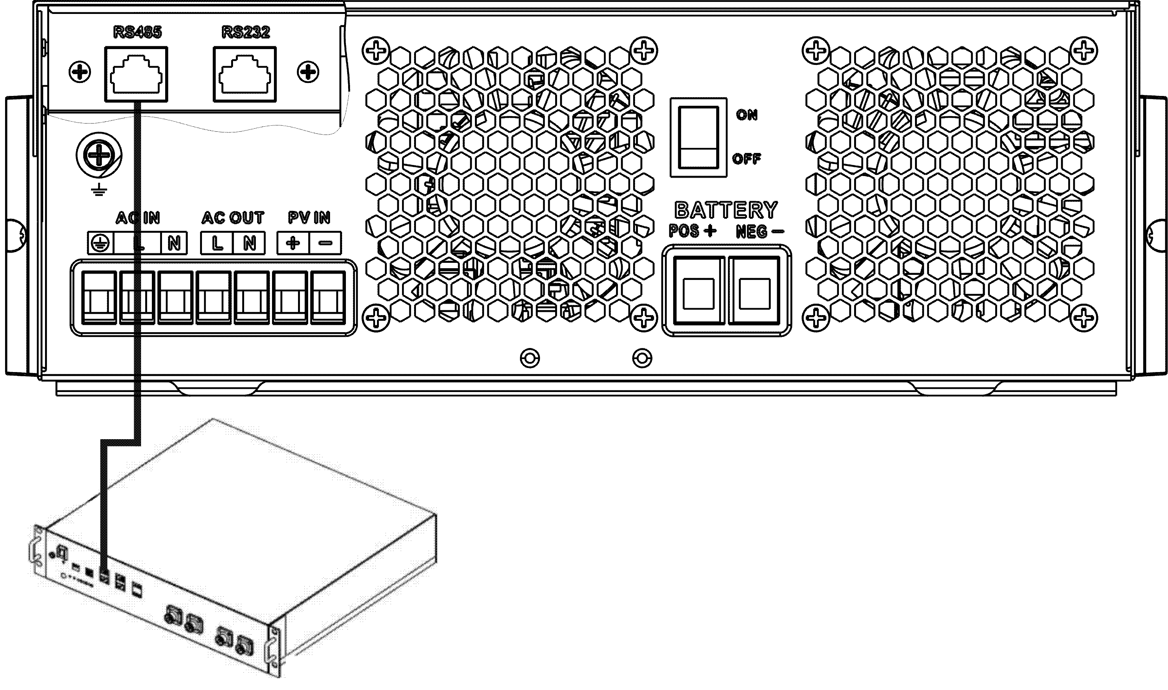

Fig 1

#### Lithium battery communication and setting

if choosing lithium battery, make sure to connect the BMS communication cable between the battery and the inverter. This communication cable delivers information and signal between lithium battery and the inverter. This information is listed below:

● Re-configure charging voltage, charging current and battery discharge cut-off voltage according to the lithium battery parameters.

● Have the inverter start or stop charging according to the status of lithium battery.

#### Connect the end of RS485 of battery to RS485 communication port of inverter

Make sure the lithium battery RS485 port connects to the inverter is Pin to Pin, the communication cable is inside of package and the inverter RS485 port pin assignment shown as below:

|  |  |
| --- | --- |
| Pin number | RS485 Port |
| PIN1 | RS485-B |
| PIN2 | RS485-A |
| PIN7 | RS485-A |
| PIN8 | RS485-B |



#### LCD setting

After connecting, you need to finish and confirm some settings as follow:

1. Select program 05 as lithium battery type.
2. Confirm program41/42/43/44/45 setting value.

**Note:** Program 43/44/45 are only available with successful communication, they will replace the Program 12/13/29 function, at the same time, program 12/13/29 become unavailable.

#### LCD Display

If communication between the inverter and battery is successful, there is some information showing on the LCD as follow：

|  |  |  |
| --- | --- | --- |
| Item | **Description** | **LCD display** |
| 1 | Communication successful icon | * will be flashing |
| 2 | Max lithium battery charging voltage | Max lithium battery charging voltage is 56.0V. |
| 3 | Max lithium battery charging current | Max lithium battery charging current is 40A. |
| 4 | Lithium battery discharging is forbidden | will flash once every 1 second |
| 5 | Lithium battery charging is forbidden | will flash once every 2 second |
| 6 | Lithium battery SOC(%) | Lithium battery SOC is 63AH and 60% |

**Setting for PYLON US2000 lithium battery**

1). PYLONTECH US2000 lithium battery setting:

Dip Switch: There are 4 Dip Switches that sets different baud rate and battery group address. If switch position is turned to the “OFF” position, it means “0”. If switch position is turned to the “ON” position, it means “1”.

Dip 1 is “ON” to represent the baud rate 9600.

Dip 2, 3 and 4 are reserved for battery group address.

Dip switch 2, 3 and 4 on master battery (first battery) are to set up or change the group address.

**NOTE:** “1” is upper position and “0” is bottom position.



2). Process of install

Step 1. Use the RS485 cable to connect inverter and Lithium battery as Fig 1.

Step 2. Switch on Lithium battery.



Step 3. Press more than three seconds to start Lithium battery, power output ready.



Step 4. Turn on the inverter.

Step 5. Be sure to select battery type as “Li2” in LCD program 5.

If communication between the inverter and battery is successful, the battery icon on LCD display will light

**Setting for lithium battery without communication**

This suggestion is used for lithium battery application and avoid lithium battery BMS protection without communication, please finish the setting as follow:

1.Before starting setting，you must get the battery BMS specification：

A. Max charging voltage

B. Max charging current

C. Discharging protection voltage

2.Set battery type as“USE”（user-defined）

|  |  |  |  |
| --- | --- | --- | --- |
| 05 | Battery type | AGM (default) | Flooded |
| **User-Defined** | If “User-Defined” is selected, battery charge voltage and low DC cut-off voltage can be set up in program 26,  27 and 29. |

3. Set C.V voltage as Max charging voltage of BMS-0.5V.

|  |  |  |
| --- | --- | --- |
| 26 | Bulk charging voltage (C.V voltage) | If self-defined is selected in program 5, this program can be set  up. But the setting value must be more than or equal the value of program27. Increment of each click is 0.1V.  12V models: Default 14.1V, setting range is from 12.0V to 15.5V,  24V models: Default 28.2V, setting range is from 24.0V to 30.0V ,  48V models: Default 56.4V, setting range is from 48.0V to 62.0V. |

4. Set floating charging voltage as C.V voltage.

|  |  |  |
| --- | --- | --- |
| 27 | Floating charging voltage | If self-defined is selected in program 5, this program can be set  up.  12V models default setting: 13.5V  Setting range is from 12.0V to the value of program 26  24V models default setting: 27.0V  Setting range is from 24.0V to the value of program 26  48V models default setting: 54.0V  Setting range is from 48.0V to the value of program 26 |

5. Set Low DC cut-off voltage ≥discharging protection voltage of BMS+2V.

|  |  |  |
| --- | --- | --- |
| 29 | Low DC cut-off voltage | If self-defined is selected in program 5, this program can be set up.  The setting value must be less than the value of program12. Increment of each click is 0.1V.Low DC cut-off voltage will be fixed to setting value no matter what percentage of load is connected.  12V models default setting: 10.5v  Setting range is from 10.0V to 13.5V  24V models default setting: 21.0v  Setting range is from 20.0V to 27.0V  48V models default setting: 42.0V  Setting range is from 40.0V to 54.0V |

6. Set Max charging current which must be less than the Max charging current of BMS.

|  |  |  |  |
| --- | --- | --- | --- |
| 02 | Maximum charging current: To configure total charging current for solar and utility chargers.  (Max. charging current = utility charging current + solar charging current) | 60A (default) | If selected, acceptable charging current range will be within 1- Max. charging current of SPEC，but it shouldn’t be less than the AC charging current （program 11） |

7. Setting voltage point back to utility source when selecting “SBU priority” or “Solar first” in program 01.The setting value must be ≥Low DC cut-off voltage**+1V**，or else the inverter will have a warning as battery voltage low.

|  |  |  |
| --- | --- | --- |
| 12 | Setting voltage point back to utility source when selecting “SBU priority” or “Solar first” in program 01. | **48V models:**46V (default)  Setting range is from 44.0V to 57.2V for 48v model, but the max setting value must be less than the value of program13. |
| **24V models:**23V (default)  Setting range is from 22.0V to 28.6V for 24v model, but The max setting value must be less than the value of program13. |
| **12V models:**11.5V (default)  Setting range is from 11.0V to 14.3V for 12v model, but The max setting value must be less than the value of program13. |

Remark:

1.you’d better to finish setting without turn on the inverter(just let the LCD show, no output);

## 2.when you finish setting, please restart the inverter.Fault Reference Code

|  |  |  |
| --- | --- | --- |
| **Fault Code** | **Fault Event** | **Icon on** |
| 01 | Over temperature of inverter module | C:\Users\Administrator\Desktop\图片1.png图片1 |
| 02 | Over temperature of DCDC module |  |
| 03 | Battery voltage is too high |  |
| 04 | Over temperature of PV module | C:\Users\Administrator\Desktop\图片2.png图片2 |
| 05 | Output short circuited. |  |
| 06 | Output voltage is too high. |  |
| 07 | Overload time out |  |
| 08 | Bus voltage is too high |  |
| 09 | Bus soft start failed |  |
| 10 | PV over current |  |
| 11 | PV over voltage |  |
| 12 | DCDC over current |  |
| 13 | Over current or surge |  |
| 14 | Bus voltage is too low |  |
| 15 | Inverter failed (Self-checking) |  |
| 18 | Op current offset is too high |  |
| 19 | Inverter current offset is too high |  |
| 20 | DC/DC current offset is too high |  |
| 21 | PV current offset is too high |  |
| 22 | Output voltage is too low |  |
| 23 | Inverter negative power |  |

## Warning Indicator

|  |  |  |  |
| --- | --- | --- | --- |
| **Warning Code** | **Warning Event** | **Audible Alarm** | **Icon flashing** |
| 02 | Temperature is too High | Beep three times every second |  |
| 04 | Low battery | Beep once every second |  |
| 07 | Overload | Beep once every 0.5 second |  |
| 10 | Output power derating | Beep twice every 3 seconds |  |
| 14 | Fan blocked | None |  |
| 15 | PV energy is low | Beep twice every 3 seconds |  |
| 19 | Lithium Battery communication is failed | Beep once every 0.5 second |  |
| 21 | Lithium Battery over current | None |  |
|  | Battery equalization | None |  |
|  | Battery is not connected | None |  |

# SPECIFICATIONS

## Table 1 Line Mode Specifications

|  |  |  |  |  |  |
| --- | --- | --- | --- | --- | --- |
| **INVERTER MODEL** | **1.5KVA** | **3.5KVA** | **3.5KVA** | **5.5KVA** | **6.2KVA** |
| **PVmax=160V** | |
| **Input Voltage Waveform** | Sinusoidal (utility or generator) | | | | |
| **Nominal Input Voltage** | 230Vac | | | | |
| **Low Loss Voltage** | 170Vac±7V (UPS)  90Vac±7V (Appliances) | | | | |
| **Low Loss Return Voltage** | 180Vac±7V (UPS);  100Vac±7V (Appliances) | | | | |
| **High Loss Voltage** | 280Vac±7V | | | | |
| **High Loss Return Voltage** | 270Vac±7V | | | | |
| **Max AC Input Voltage** | 300Vac | | | | |
| **Nominal Input Frequency** | 50Hz / 60Hz (Auto detection) | | | | |
| **Low Loss Frequency** | 40±1Hz | | | | |
| **Low Loss Return Frequency** | 42±1Hz | | | | |
| **High Loss Frequency** | 65±1Hz | | | | |
| **High Loss Return Frequency** | 63±1Hz | | | | |
| **Output Short Circuit Protection** | Battery mode: Electronic Circuits | | | | |
| **Efficiency (Line Mode)** | >95% ( Rated R load, battery full charged ) | | | | |
| **Transfer Time** | 10ms typical (UPS); 20ms typical (Appliances) | | | | |
| **Output power derating:**  When AC input voltage drops to 95V or 170V depending on models, the output power will be derated. | Output Power  Rated Power 50%  Power  90V 170V 280V Input Voltage | | | | |

## Table 2 Inverter Mode Specifications

|  |  |  |  |  |  |
| --- | --- | --- | --- | --- | --- |
| **INVERTER MODEL** | **1.5KVA** | **3.5KVA** | **3.5KVA** | **5.5KVA** | **6.2KVA** |
| **PVmax=160V** | |
| **Rated Output Power** | 1.5KVA/1.5KW | 3.5KVA/3.5KW | | 5.5KVA/5.5KW | 6.2KVA/6.2KW |
| **Output Voltage Waveform** | Pure Sine Wave | | | | |
| **Output Voltage Regulation** | 230Vac±5% | | | | |
| **Output Frequency** | 50Hz or 60Hz | | | | |
| **Peak Efficiency** | 94% | | | | |
| **Surge Capacity** | 2* rated power for 5 seconds | | | | |
| **Nominal DC Input Voltage** | 12Vdc | 24Vdc | | 48Vdc | |
| **Cold Start Voltage** | 11.0Vdc | 23.0Vdc | | 46.0Vdc | |
| **Low DC Warning Voltage**  Just for AGM and Flooded  @ load < 20%  @ 20% ≤ load < 50%  @ load ≥ 50% | 11.0Vdc  10.7Vdc  10.1Vdc | 22.0Vdc  21.4Vdc  20.2Vdc | | 44.0Vdc  42.8Vdc  40.4Vdc | |
| **Low DC Warning Return Voltage**  Just for AGM and Flooded  @ load < 20%  @ 20% ≤ load < 50%  @ load ≥ 50% | 11.5Vdc  11.2Vdc  10.6Vdc | 23.0Vdc  22.4Vdc  21.2Vdc | | 46.0Vdc  44.8Vdc  42.4Vdc | |
| **Low DC Cut-off Voltage**  Just for AGM and Flooded  @ load < 20%  @ 20% ≤ load < 50%  @ load ≥ 50% | 10.5Vdc  10.2Vdc  9.6Vdc | 21.0Vdc  20.4Vdc  19.2Vdc | | 42.0Vdc  40.8Vdc  38.4Vdc | |

## Table 3 Charge Mode Specifications

|  |  |  |  |  |  |  |
| --- | --- | --- | --- | --- | --- | --- |
| **Utility Charging Mode** | | | | | | |
| **INVERTER MODEL** | | **1.5KVA** | **3.5KVA** | **3.5KVA** | **5.5KVA** | **6.2KVA** |
| **PVmax=160V** | |
| **Max Charging Current (PV+AC)**  **(@ VI/P=230Vac)** | | 120Amp | | 100Amp | 100Amp | 120Amp |
| **Max Charging Current**  **(AC)**  **(@ VI/P=230Vac)** | | 80Amp | | | | |
| **Bulk Charging Voltage** | **Flooded**  **Battery** | 14.6Vdc | 29.2Vdc | | 58.4Vdc | |
| **AGM / Gel**  **Battery** | 14.1Vdc | 28.2Vdc | | 56.4Vdc | |
| **Floating Charging Voltage** | | 13.5Vdc | 27Vdc | | 54Vdc | |
| **Overcharge Protection** | | 15.5 Vdc | 33Vdc | | 63Vdc | |
| **Charging Algorithm** | | 3-Step | | | | |
| **Charging Curve** | | Battery Voltage, per cell Charging Current, %  2.43Vdc (2.35Vdc) Voltage  2.25Vdc  100%  50%  T0 T1  T1 = 10* T0, minimum 10mins, maximum 8hrs  Current  Time  Bulk Absorption Maintenance  (Constant Current) (Constant Voltage) (Floating) | | | | |
| **Solar Input** | | | | | | |
| **INVERTER MODEL** | | **1.5KVA** | **3.5KVA** | **3.5KVA** | **5.5KVA** | **6.2KVA** |
| **PVmax=160V** | |
| **Rated Power** | | 900W | 1500W | 4000W | 5500W | 6500W |
| **Max. PV Array Open Circuit**  **Voltage** | | 160Vdc | | 500Vdc | | |
| **PV Array MPPT Voltage**  **Range** | | 30Vdc~160Vdc | | 60Vdc~500Vdc | | |
| **Max. Input Current** | | 30A | 50A | 15A | 18A | 27A |
| **Max. Charging Current(PV)** | | 60A | | 100A | 100A | 120A |

## Table 4 General Specifications

|  |  |  |  |  |  |
| --- | --- | --- | --- | --- | --- |
| **INVERTER MODEL** | **1.5KVA** | **3.5KVA** | **3.5KVA** | **5.5KVA** | **6.2KVA** |
| **PVmax=160V** | |
| **Operating Temperature**  **Range** | -10°C to 55°C | | | | |
| **Storage temperature** | -15°C~ 60°C | | | | |
| **Humidity** | 5% to 95% Relative Humidity (Non-condensing) | | | | |
| **Dimension(D*W*H), mm** | 358x295x105 | | | 438x295x105 | |
| **Net Weight, kg** | 5.8 | 6.2 | | 8.2 | 8.7 |

# TROUBLE SHOOTING

|  |  |  |  |
| --- | --- | --- | --- |
| **Problem** | **LCD/LED/Buzzer** | **Explanation / Possible cause** | **What to do** |
| Unit shuts down automatically  during startup process. | LCD/LEDs and buzzer will be active for 3  seconds and then complete off. | The battery voltage is too low | 1. Re-charge battery. 2. Replace battery. |
| No response after power on. | No indication. | 1. The battery voltage is far too low. 2. Battery polarity is connected reversed. | 1. Check if batteries and the wiring are connected well. 2. Re-charge battery. 3. Replace battery. |
| Mains exist but the unit works in battery mode. | Input voltage is displayed as 0 on the LCD and green LED is  flashing. | Input protector is tripped | Check if AC breaker is tripped and AC wiring is connected well. |
| Green LED is flashing. | Insufficient quality of AC power. (Shore or Generator) | 1. Check if AC wires are too thin and/or too long. 2. Check if generator (if applied) is working well or if   input voltage range setting is correct. (UPS→Appliance) |
| Green LED is flashing. | Set “Solar First” as the priority of output source. | Change output source priority to Utility first. |
| When the unit is turned on, internal  relay is switched on and off repeatedly. | LCD display and LEDs are flashing | Battery is disconnected. | Check if battery wires are connected well. |
| Buzzer beeps continuously and red LED is on. | Fault code 07 | Overload error. The inverter is overload 110% and time is up. | Reduce the connected load by  switching off some equipment. |
| Fault code 05 | Output short circuited. | Check if wiring is connected well and remove abnormal  load. |
| Fault code 02 | Internal temperature of inverter component is over 100°C. | Check whether the air flow of the unit is blocked or whether the ambient temperature is too high. |
| Fault code 03 | Battery is over-charged. | Return to repair center. |
| The battery voltage is too high. | Check if spec and quantity of batteries are meet  requirements. |
| Fault code 06/22 | Output abnormal (Inverter voltage below than 190Vac or is higher than 260Vac) | 1. Reduce the connected load. 2. Return to repair center |
| Fault code 08/09/15 | Internal components failed. | Return to repair center. |
| Fault code 13 | Over current or surge. | Restart the unit, if the error happens again, please return to repair center. |
| Fault code 14 | Bus voltage is too low. |
| Another fault code |  | If the wires is connected  well, please return to repair center. |

371-00010-04